Alejandro Ceballos

10-25-2025

CS500-1

Module 3 Critical Thinking Assignment

# Pseudocode for Assignment 2

PROGRAM START

// Part 1: Meal Total Calculation //

get user input for variable meal_charge

variable tip = meal_charge * 18%  
 variable tax = meal_charge * 7%  
 variable total_price = meal_charge + tip + tax

display "Total Tip(18%):" tip formatted to 2 decimal places  
 display "Total Tax(7%):" tax formatted to 2 decimal places  
 display "Total Price:" total_price formatted to 2 decimal places  
  
 // Part 2: Alarm Time Calculation //

get user input for variable current_time  
 get user input for variable wait_hours

variable alarm_time = (current_time + wait_hours) MOD 24  
 display alarm_time

END PROGRAM

# Source Code for Assignment 2

# Author: Alejandro Ceballos

# Date: 2025-10-25

# Module 3: Critical Thinking Assignment 2

# Part 1: Write a program that calculates the total amount of a meal purchased at a restaurant.

# The program should ask the user to enter the charge for the food and then calculate the amounts with an 18 percent tip and 7 percent sales tax.

# Display each of these amounts and the total price.

# Part 2: Many people keep time using a 24-hour clock (11 is 11am and 23 is 11pm, 0 is midnight).

# If it is currently 13 and you set your alarm to go off in 50 hours, it will be 15 (3pm).

# Write a Python program to solve the general version of the above problem.

# Ask the user for the time now (in hours) and then ask for the number of hours to wait for the alarm.

# Your program should output what the time will be on a 24-hour clock when the alarm goes off.

# // Part 1: Meal Total Calculation //

print("// Part 1: Meal Total Calculation //")

meal_charge = float(input("Enter the price for the meal: "))

# Calculate tip, tax, and then total price

tip = meal_charge * 0.18

tax = meal_charge * 0.07

total_price = meal_charge + tip + tax

# Display totals

print(f"Total Tip(18%): {tip:.2f}")

print(f"Total Tax(7%): {tax:.2f}")

print(f"Total Price: {total_price:.2f}", end="\n\n")

# // Part 2: Alarm Time Calculation //

print("// Part 2: Alarm Time Calculation //")

# get our inputs

current_time = int(input("Enter your current time (0-23 hours): "))

wait_hours = int(input("Enter the number of hours to wait for the alarm: "))

# add wait time to current time then do a modulo 24 to adjust for 24hr format

alarm_time = (current_time + wait_hours) % 24

print("The alarm will sound at hour:", alarm_time)

# Output

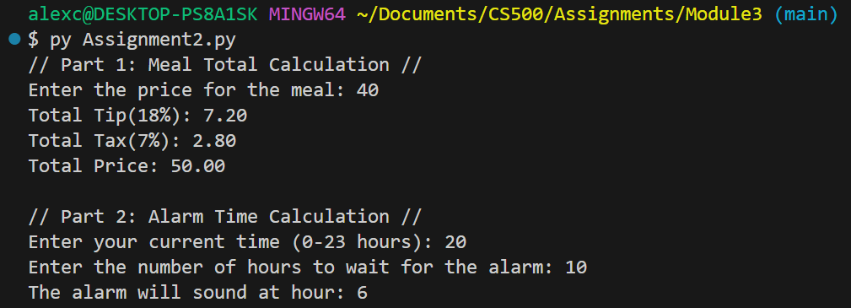

GIT REPO LINK: [GIT REPOSITORY](https://github.com/AlejandroBrick/CS500)